<Logo of Swift user> | Swift - Customer Security Programme  Assessment Report – Year <2026>  CSCF baseline v2026

<Swift user full legal name>
<Swift user HQ city, country>
BICs: <Swift user BICs> / Architecture types: <assessed architecture types>

<DRAFT/FINAL> CSP Assessment Report

Assessor company name: <Assessor company name – as applicable>
Delivered by: <Assessor lead name>

Assessment date: <Month Year>
Report Date: <reporting Day Month Year>

Assessors | Distributed to
Lead: <Name of lead> | <Name of Swift user contact persons>
Team member: <Name of assessors>
Table of Contents
Preface 3
1 Executive Summary 4
Outsourcing of CSP In-scope Components 5
2 Assessment Result 7
3 Detailed Exceptions 9
4 Assessor legal notice (optional) 9

Preface

About this document
To comply with the Swift Customer Security Program (CSP), Swift requires the submission of an annual security attestation supported by an independent assessment, as described in the Swift Independent Assessment Framework (IAF).
This assessment report is to provide <name of the Swift user assessed> (further referred to as the ‘Swift user’) with Reasonable Comfort on its level of compliance against the applicable security controls (mandatory, and optionally advisory) as further described in the Customer Security Controls Framework (CSCF) version <version’s year of assessed CSCF> as they were evaluated by the assessor.
The assessment covered the following BICs of the Swift user: <List of BICs covered>.
This report is expected to support the submission by the Swift user of its attestation in the Know-Your-Customer Security Attestation (KYC-SA) application.
Swift users do not need to provide a copy of the assessment report to Swift. However, it is expected that the Swift user securely stores the report and output. The assessment does not give any opinion or level of compliance on any other service(s) provided by the Swift user to its customers.
Confidentiality Notice
This report must be considered as Confidential.
This report must be considered as Confidential. This assessment does not give any opinion or level of compliance on any other services provided by <Swift user>. We do not assume responsibility to anyone other than <Swift user> for this report or the conclusion we formed.
Disclaimer
This report is solely intended for <Swift user>and <Swift user> (referred to as <acronym>). The assessment was based on risk base approach in line with Swift Customer Security Controls Framework (CSCF) <vYYYY> as to whether <acronym> suitably designed and implemented controls applicable to them to achieve the control objectives. The report should be used for its intended purpose and <acronym> only.

Executive Summary
Assessment Methodology
The assessment covered the controls in place and applicable to the components in scope of the Swift user (including but not limited to physical and virtualisation security, environment protection, data and data flows security, systems and software security and hardening, logical access limitation, internet access restriction, logging and monitoring, vulnerability testing, staff training, incident response planning).
The report gives reasonable comfort of the controls design and effectiveness (as per control definition) at the time of the assessment. It does not provide any conclusion about controls operational effectiveness during a given period in the past or does not imply any future compliance.
The assessment was primarily based on <as applicable: documents inspection (examples: infrastructure and network diagrams, policies, procedures, guidelines, systems extracts), physical inspection of the data centre(s), interviews, observations, demo’s and reperformances> in collaboration with the Swift user’s Subject Matter Experts (SMEs).
Testing was performed at the level of detail that the assessors considered necessary to obtain a reasonable level of comfort in the Swift user’s compliance with the applicable controls, and in alignment with Swift guidelines described in the Independent Assessment Framework.
Assessment Scope
At the time of the assessment, the implementation of the Swift user’s infrastructure was identified and confirmed as per the below table:
BIC | Entity Name | Architecture type | Connectivity component
<BIC> | <Entity name> | <Architecture type> | <Component name>
Example:  BICABCDE | Bank of Luna HQ | Architecture type A1 | Swift Alliance Gateway
Example:  BICABCDD | Bank of Luna Local | Architecture type A4 | MQ Server
… | … | … | …

<if applicable> At the time of the assessment, the Swift user was connecting to Swift using a Service Bureau/L2BA/Business Connect/Enabler/Group Hub provider. The provider was <name of the provider/group-hub> and was confirmed to be compliant with the appropriate Swift provider programme or with the CSP>.
The assessment covered the components listed below and owned by the Swift user, regardless of whether they were physically located on the customer’s premise or outsourced to a third-party service provider (further referred to as “Outsourcing Agent”):
Components (BICs) | Type | Location (On premises or outsourced)
<component name (BICs)> | <component type> | <On premises or outsourced>
Example:  IBM MQ Server as connector (BICABCDD) | Customer connector | Outsourced in company XYZ
Example:  Operator computers (All BICs) | General-operator PC | On premises
Example:  Alliance Gateway (BICABCDE) | Communication interface | On premises
… | … | …

<Optional> The below high-level infrastructure diagram provides a high-level view of the assessed components as implemented: <include high-level diagrams of the Swift user infrastructures assessed, including production/live and disaster/recovery, as applicable>
<BICs>:
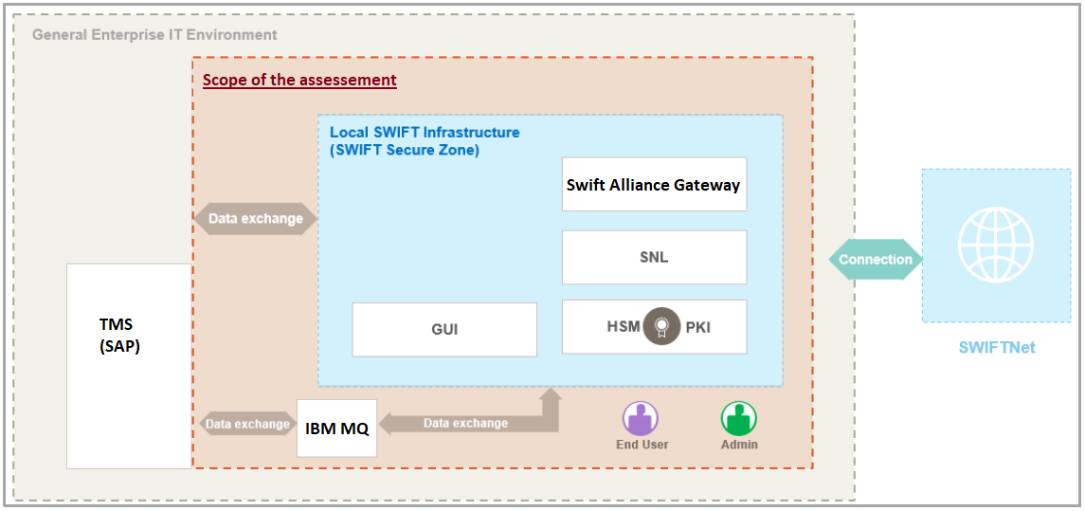

Outsourcing of CSP In-scope Components
<include below paragraph if a part or the whole of the assessed Swift user’s infrastructure was outsourced to a third-party service provider acting as an Outsourcing Agent – otherwise mention “No components were outsourced”>
A part of the components owned by <name of assessed Swift user> was hosted, operated and/or maintained by a third-party service provider (including cloud provider) acting as an Outsourcing Agent (further described in the Swift documentation: Outsourcing Agent Guidelines).
The table below lists the outsourcing agents supporting the CSP in-scope components of the Swift user, and which report(s) was relied on to obtain a reasonable level of comfort on controls effectiveness at the outsourcing agent side:
Outsourcing Agent | Type of service | Components outsourced (BICs) | Responsibility | Type of comfort obtained
<Name of third-party provider> | <Service provided: datacenter, Saas, Iaas,… > | <List of components outsourced (BICs)> | <Hosting, Operations, hosting & operations> | <type of third-party assurance provided to support controls conclusion, or assessment report>
Example:  ABC cloud | Public cloud IaaS | Swift Alliance Gateway (BICABCDE) | Hosting | ISAE 3000
Example:  Company XYZ | Private cloud SaaS | Customer Connector MQ server (BICABCDD) | Hosting and Operations | SOC-2

Assessment Result
As per the assessed architecture type, the assessment covered <# controls> controls composed of:
- <# mandatory controls> mandatory controls, and
- <# advisory controls> advisory controls
as defined in the CSCF <v2026>.
Find in the below table the controls assessed with their compliance level: <important note: in the below table, the control 1.1 shows possible values for each column, and controls 1.2 to 1.5 are examples on how to fill the results - all to be replaced with adequate information>
Controls | Architecture Type |  |  |  |  | Preparation Phase | Testing phase
Controls | A1 | A2 | A3 | A4 | B | Last tested against CSCF version | How was conclusion reached? | Compliance conclusion | Observations or comments (BICs)
1 Restrict Internet Access and Protect Critical Systems from General IT Environment
1.1 SWIFT Environment Protection | ● | ● | ● |  |  | CSCF v<Year>  or  <Not applicable>  or  <Not tested> | <Relied on previous report>  or  <Fully tested>  or  <relied on external report>  or  <Not applicable>  Or  <Not tested> | <Compliant>  or  <Not compliant>  or  <Not applicable>
1.2 Operating System Privileged Account Control | ● | ● | ● | ● | ● | CSCF v2026 | Fully tested | Uncompliant | Exception 1: Inappropriate usage of built-in admin account (BICABCDE)
1.3 Virtualisation or Cloud Platform Protection | ● | ● | ● | ● | ● | Not applicable | Not applicable | Not applicable | No virtualisation used (all BICs)
1.4 Restriction of Internet Access | ● | ● | ● | ● | ● | CSCF v2026 | Relied on external report | Compliant | ISAE3000 relied on
1.5 Customer Environment Protection |  |  |  | ● |  | CSCF v2025 | Relied on previous CSP report | Compliant
2 Reduce Attack Surface and Vulnerabilities
2.1 Internal Data Flow Security | ● | ● | ●
2.2 Security Updates | ● | ● | ● | ● | ●
2.3 System Hardening | ● | ● | ● | ● | ●
2.4 Back Office Data Flow Security | ● | ● | ● | ●
2.5A External Transmission Data Protection | ● | ● | ● | ●
2.6 Operator Session Confidentiality and Integrity | ● | ● | ● | ● | ●
2.7 Vulnerability Scanning | ● | ● | ● | ● | ●
2.8 Outsourced Critical Activity Protection | ● | ● | ● | ● | ●
2.9 Transaction Business Controls | ● | ● | ● | ● | ●
2.10 Application Hardening | ● | ● | ●
2.11A RMA Business Controls | ● | ● | ● | ● | ●
3 Physically Secure the Environment
3.1 Physical Security | ● | ● | ● | ● | ●
4 Prevent Compromise of Credentials
4.1 Password Policy | ● | ● | ● | ● | ●
4.2 Multi-Factor Authentication | ● | ● | ● | ● | ●
5 Manage Identities and Separate Privileges
5.1 Logical Access Control | ● | ● | ● | ● | ●
5.2 Token Management | ● | ● | ● | ● | ●
5.3A Staff Screening Process | ● | ● | ● | ● | ●
5.4 Password Repository Protection | ● | ● | ● | ● | ●
6 Detect Anomalous Activity to Systems or Transaction Records
6.1 Malware Protection | ● | ● | ● | ● | ●
6.2 Software Integrity | ● | ● | ● | ●
6.3 Database Integrity | ● | ● |  | ●
6.4 Logging and Monitoring | ● | ● | ● | ● | ●
6.5A Intrusion Detection | ● | ● | ● | ●
7 Plan for Incident Response and Information Sharing
7.1 Cyber Incident Response Planning | ● | ● | ● | ● | ●
7.2 Security Training and Awareness | ● | ● | ● | ● | ●
7.3A Penetration Testing | ● | ● | ● | ● | ●
7.4A Scenario Risk Assessment | ● | ● | ● | ● | ●

<Name of the lead assessor>, Lead Assessor

Detailed Exceptions
Find below the list of all exceptions identified during the assessment, with their details. If an exception prevents the capability of a mandatory control to fulfil the control definition, then it must be reported as not-compliant in the KYC-SA application leading to a global non-compliance of the CSP attestation of the swift user.
Exception <number> | <Exception title – must be aligned with the table in previous chapter >
Components affected (BICs) | <List of affected components (BICs)>
Control(s) affected | <List of controls impacted by the exception>
Description | <Detailed description of the observation>
Recommendation (optional) | <Recommendation of implementation to solve the exception>

Example:
Exception 1 | Inappropriate usage of windows built-in administrator
Components affected (BICs) | All windows servers supporting the CSP components (BICABCDE)
Control(s) affected | 1.2 Operating System Privileged Account Control
Description | Built-in administrator on all windows servers supporting the Swift components were used for non-critical activities without proper usage and access management enforcement
Recommendation | Restrict built-in administrator usage for critical activities only

Assessor legal notice
This report provides an overview of the assessment and is intended for the sole purpose of <acronym> for compliance with the Swift in-scope components. Assessment was performed in accordance with Swift CSCF <v2025> and IA Framework, this report does not convey a formal assurance opinion. All general terms and conditions are applicable for this report.

A level of comfort that Management can obtain from the assessors when (a) the appropriate level of independence, objectivity, knowledges, and skills of the assessors is ensured, (b) fair validation by the assessors of control design and implementation, confirming mitigation of risks as per the control objective, and (c) noted exceptions do not materially impact the control’s ability to mitigate the risk, or alternative controls compensate for the noted deviations.
The control definition includes the control objective, the in-scope components, and the related risk-drivers as described in the CSCF
This column lists the type of external reports that can be relied on to obtain reasonable comfort about controls’ compliance level at the Outsourcing Agent side (further described in the IAF “Reliance on Another Report”). The content, scope, and coverage of the repot must be validated by the independent assessor to be allowed to be used.
Description based on CSCF v2026
Not applicable Architecture Type can be removed
This is the CSCF version the control was last tested against (typically the active CSCF version for the assessed year). In case of reliance on the previous cycle, the previous CSCF version must be specified here

